**MARMON CUTTER V4.1 Changes (12/21/2022)**

-Shrunk ground pad on footprint for U2 (MAX14575CETA+T)

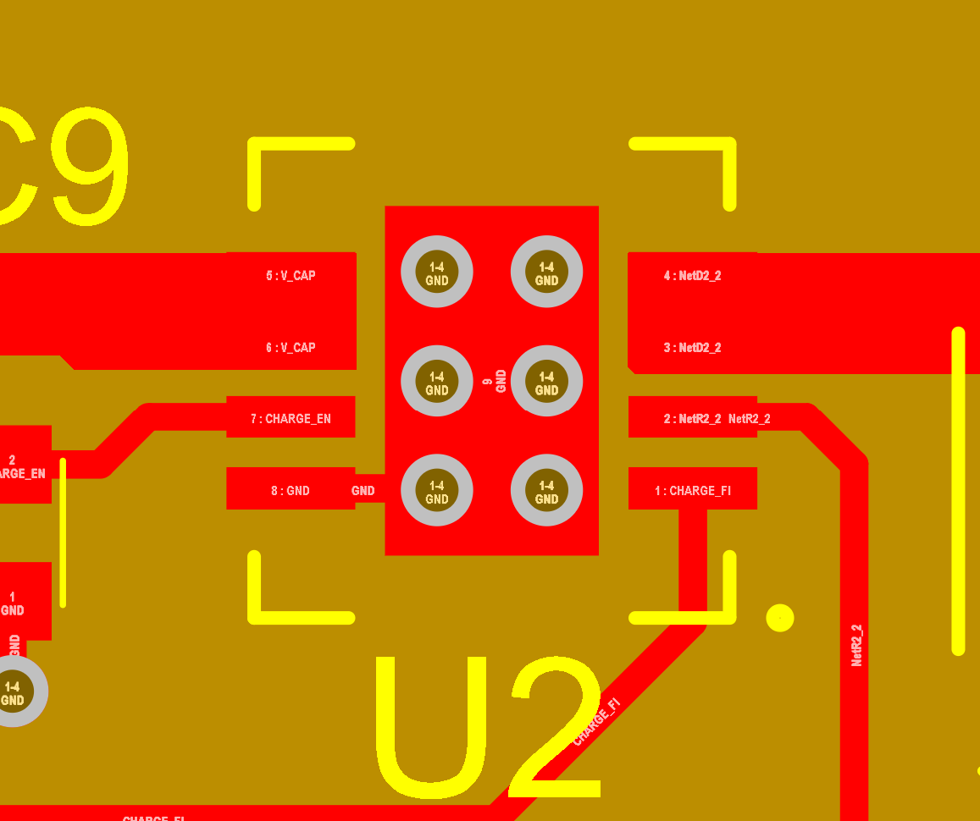 -> 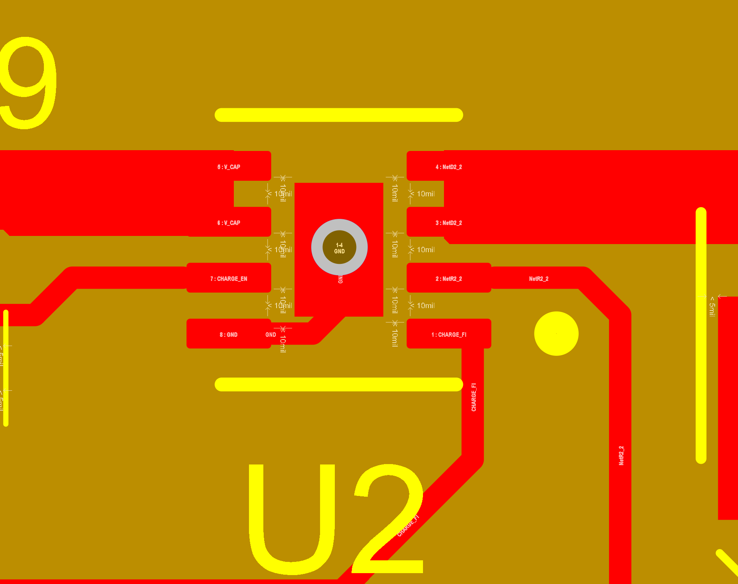

-Moved some silkscreen that was previously hidden by connectors and added a few labels

-Removed thermistor network resistors that were never added to the layout in the original design. The resistors can be added back to the schematic and included in the layout if desired. Resistor values could be calculated using info found here

https://www.ti.com/lit/an/sboa323a/sboa323a.pdf?ts=1671650481533&ref_url=https%253A%252F%252Fwww.ti.com%252Ftool%252FCIRCUIT060002

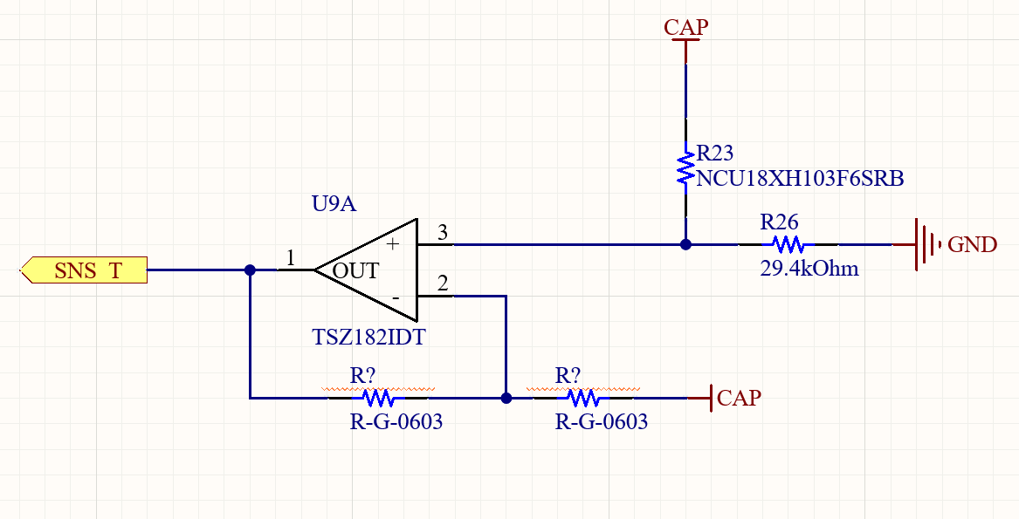->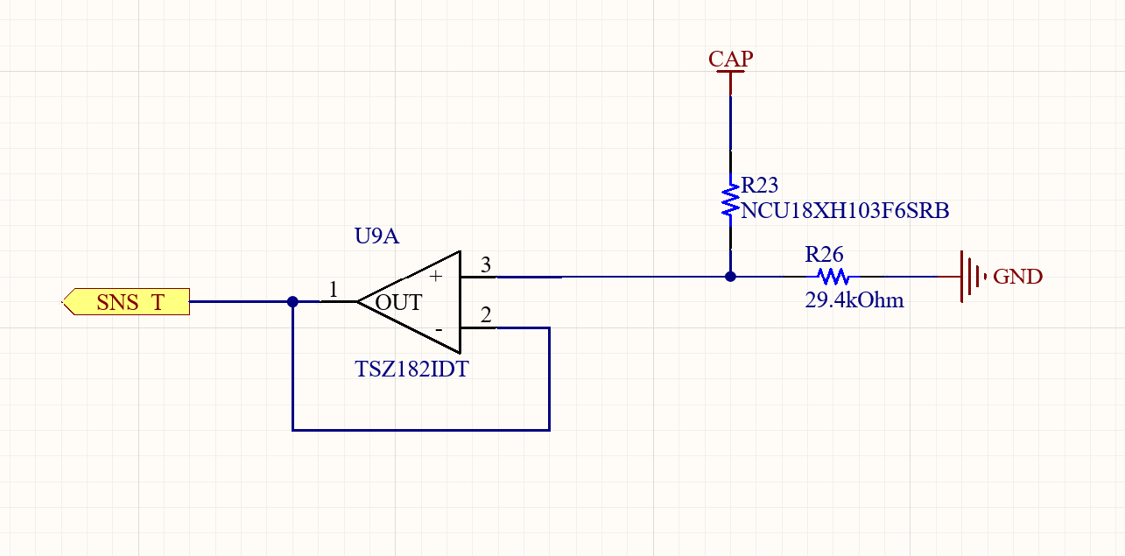

-Added test points to gate control pins

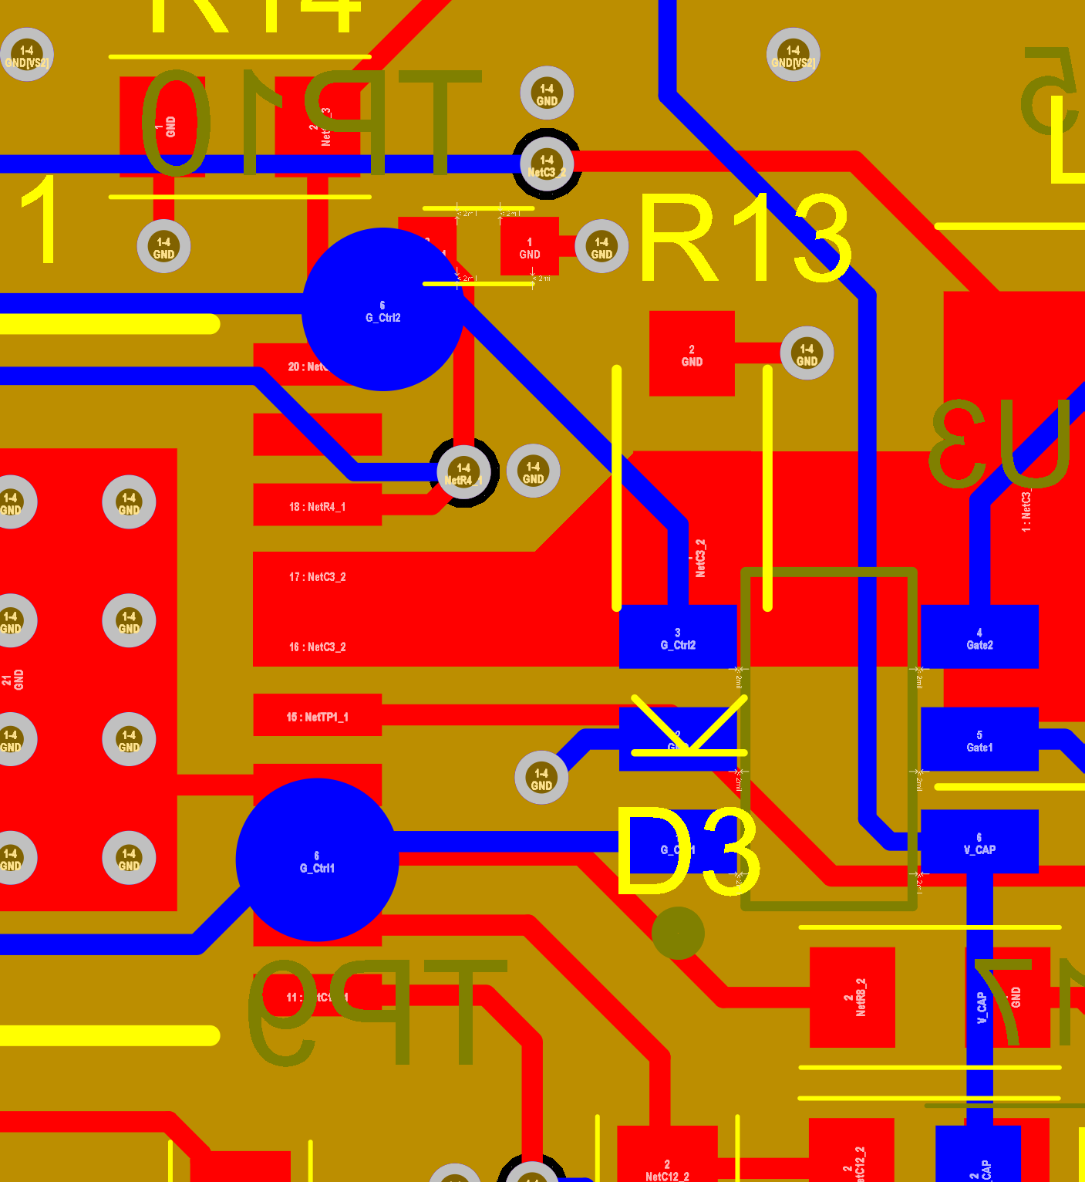

-Confirmed functionality of Gate_Ctrl2 and non-functionality of Gate_Ctrl1 with gate driver resoldered to board. Moved G_Ctrl1 to CAPC_EN since it is a pin that has consistently toggled properly and does not have low-frequency switching recommendations. Moved CAPC_EN to SNS_BAT since the SNS_BAT has also consistently worked but CAPC_EN seems like a higher priority. SNS_BAT was then moved to P0.28 which was previously unused but should be perfectly fine.

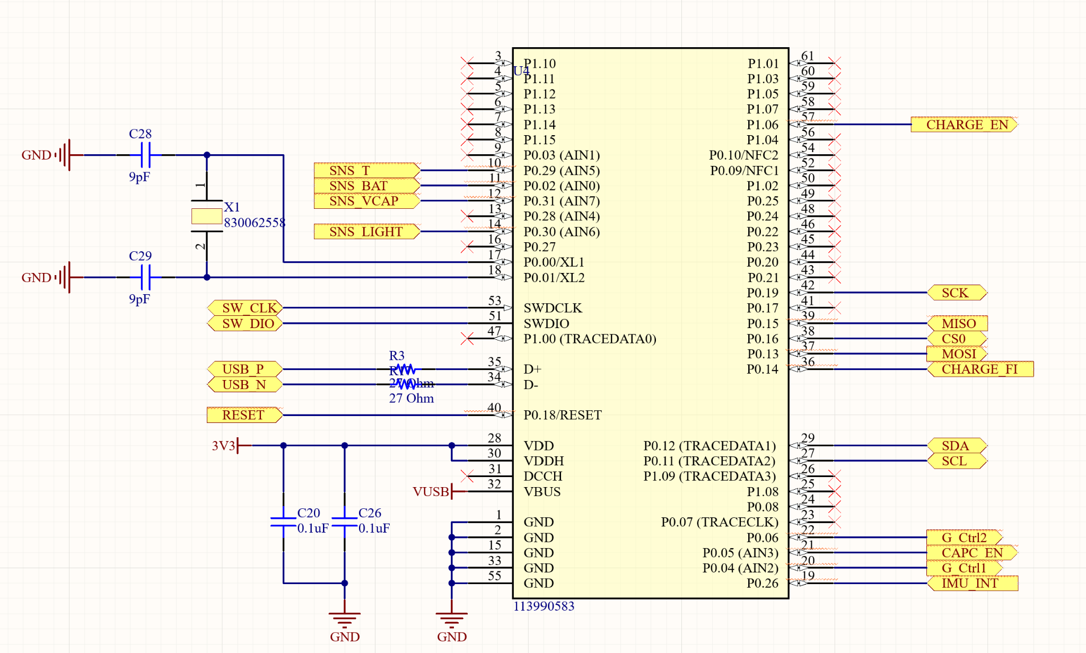->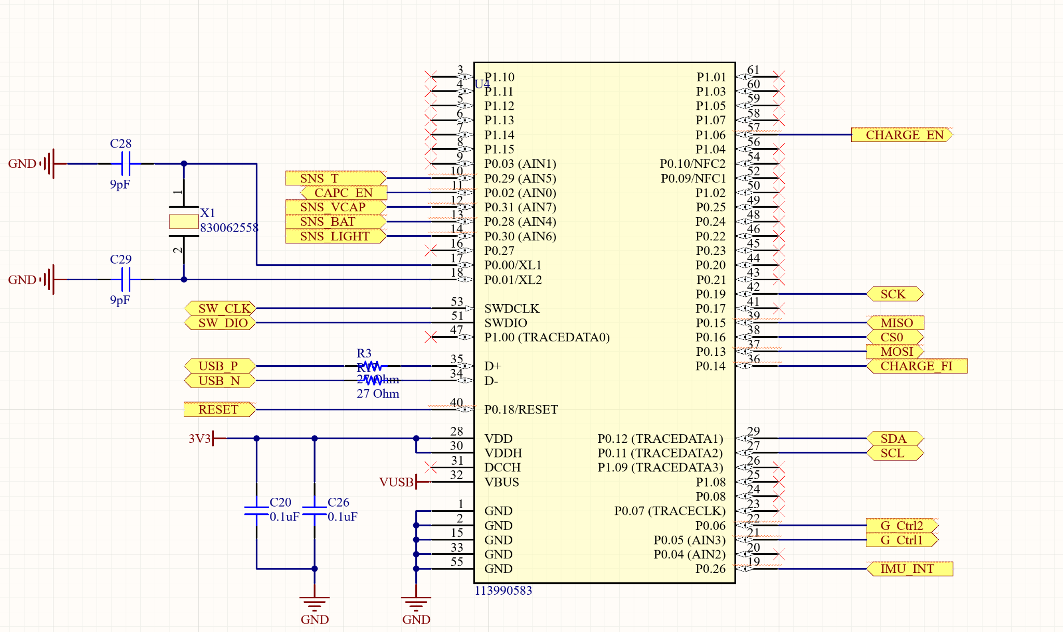

Notes/Qs:

-Did not add additional ESD protection yet since I’m not 100% sure where the best location to add it would be.

-Is there any concern regarding routing under the nrf chip?

-Anything else I’ve missed?